**TABLE OF CONTENTS**

1. Introduction
   1. Purpose………………………………………………………………..........................................3
   2. Scope………………………………………………………………………………………………………….3
   3. Definitions, Acronyms and Abbreviations…………………………….........................3
   4. References………………………………………………………………………..………………………..3
   5. Overview……………………………………………………………..........................................3
2. Actors…………………………………………………………………………………………………………………………………..3
   1. Customer……………………………………………………………..........................................3
   2. Manager……………………………………………………………………………………………………..3
   3. Chef………………………………………………………………….............................................4
   4. Webserver…………………………………………………………………………………………………..4
   5. Cashier………………………………………………………………...........................................4
   6. Database……………………………………………………………...........................................4
3. Use Cases……………………………………………………………………………………………………………………………..4
   1. Cloud Level Use Case…………………………………………………………………………………..4
4. Use Case – Chef…………………………………………………………………………………………………………………...5
5. Use Case – Customer………………………………………………………………...............................................6
6. Use Case – Delivery Boy……………………………………………………………………………………………………..12
7. Use Case – Manager………………………………………………………………..............................................14
8. Use Case – Cashier…………………………………………………………......................................................16
9. Task Analysis…………………………………………................................................................................19

**TABLE OF FIGURES**

Figure 1Cloud level Use Case Diagram 4

Figure 2 Use Case Diagram for Chef 4

Figure 3 Use Case Diagram for Customer 6

Figure 4 Use Case Diagram for Delivery Boy 11

Figure 5Use Case Diagram for Manager 13

Figure 6 Use Case Diagram for Cashier 16

Figure 7 Task Analysis 19

1. **Introduction**
   1. **Purpose**

The Use cases involves the functional requirements and it describes a set of activities that takes place inside the system. Different scenarios are explained as different use cases. It explains how the actors involved in the system communicate with each other.

* 1. **Scope**

The following use cases describe the behavior of the UHCL Patio Automation Services, how the system interacts with different users and communicate with them. Individual scenarios are described by using the use cases.

* 1. **Definitions, Acronyms and Abbreviations**

UHCL - University of Houston - Clear Lake

* 1. **References**

<http://www.uhcl.edu/procurement-payables/food-services>

* 1. **Overview**

This document consists of 4 sections, namely-

1. Introduction
2. Actors

3- Use Cases and their descriptions

1. **Actors**

**2.1) Customer**

The customer selects the food items from the menu, adds it into the cart, schedules pick up time if necessary or schedules an in-store pick up, enter his details and makes the payment.

**2.2) Manager**

The manager maintains the store, organizes food items, updates daily specials regularly and updates employment opportunities in the careers site.

**2.3) Chef**

The chef is the head cook who maintains the records of the required food items, orders the required food ingredients to the manager, prepares the food and delivers it to the customer.

**2.4) Web Server**

Web server is the website where the menu, store working hours, daily specials and employment opportunities are present.

**2.5) Cashier**

Cashier is the one who maintains all the accounts and collects amount from the customers.

**2.5) Database**

Database is the information storage system where we store all the account details, number of orders and transactions per day.

1. **Cloud Level Use Case Diagram**

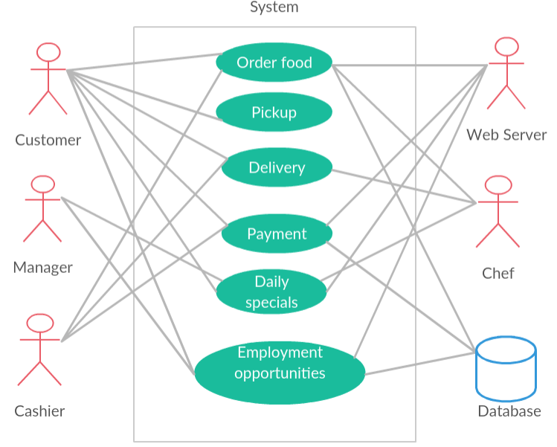

Figure 1Cloud level Use Case Diagram

1. **Chef**

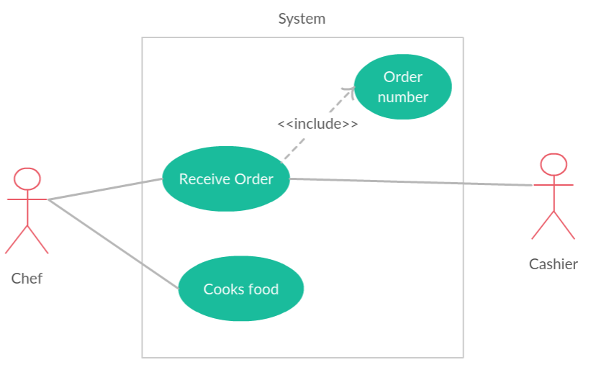

Figure 2 Use Case Diagram for Chef

* 1. **Receive order**
     1. Brief description

The chef receives the order from the customers and prepares the orders in sequence

* + 1. Pre-conditions

The chef keeps the ingredients ready anticipating the orders approximately

* + 1. Flow of events

The food is prepared after the chef receives the order details

* + 1. Basic Flow

1. Order will be displayed to the chef
2. The chef prepares the order as per the order sequence number
3. The chef prepares the food
   * 1. Alternative flow

The chef may request order from in-store

* + 1. Exception flow

The order can be cancelled

* + 1. Post-condition

The order must be prepared as per the sequence number

* 1. **Cooks food**
     1. Brief description

The chef prepares food when he receives the order

* + 1. Pre-conditions

The chef ensures that all the ingredients are ready to cook

* + 1. Flow of events

After receiving the order, the cook prepares the food as per the customer requirements

* + 1. Basic Flow

1. The customer places the order
2. Order number is generated
3. The cook prepares food according to the requirements of the customer
   * 1. Alternative flow

The chef can supply the pre-cooked food, if the requirement of the customer matches with the existing order

* + 1. Exception flow

The chef cannot prepare the food if there are no ingredients that are required to cook.

* + 1. Post-condition

After the food is cooked, the chef intimates that the order is ready for delivery.

1. **Customer**

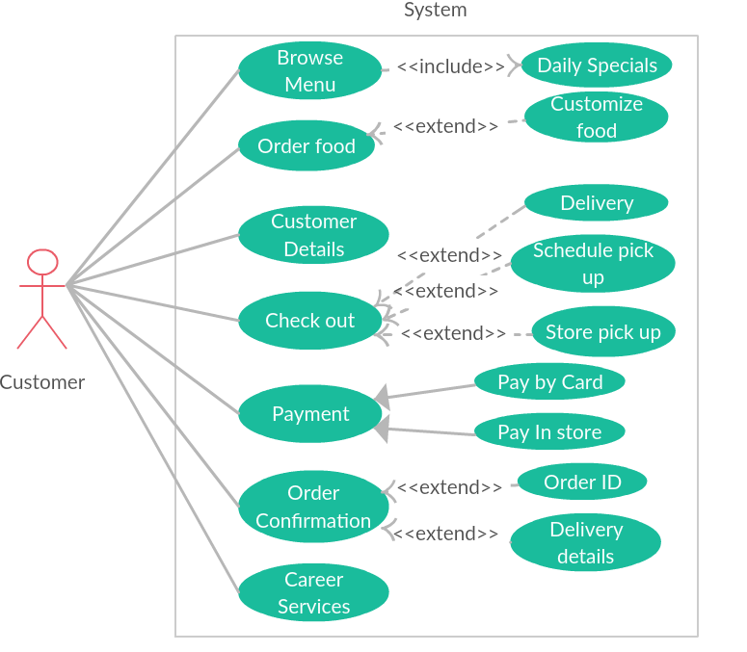

Figure 3 Use Case Diagram for Customer

* 1. **Browse Menu**
     1. Brief description

The customer browses the menu, selects the items from the menu and adds it into the cart. He also views the daily specials available on that day.

5.1.2) Pre-conditions

No pre-condition

5.1.3) Flow of events

The customer selects the food items and places order.

5.1.4) Basic Flow

a. Customer browses the food

b. Customer selects the food

c. Adds the selected food into the cart

5.1.5) Alternative flow

The customer can go in store and search the menu and select items.

5.1.6) Exception flow

The customer places an order that is out of stock

5.1.7) Post-condition

The customer can customize the order and can view the daily specials available.

**5.2) Order Food**

5.2.1) Brief description

The order is placed. Order can be customized if necessary.

5.2.2) Pre-conditions

Customization of order must be done prior if necessary

5.2.3) Flow of events

The customer places an order and moves to check out

5.2.4) Basic Flow

a. Finalizes the order

b. Place an order

1. Full name

2. Email address

3. Phone number

5.2.5) Alternative flow

Place an in-store order

5.2.6) Exception flow

The order can be placed after the store closing hours

5.2.7) Post-condition

The customer chooses the type of pick up or chooses delivery.

**5.3) Customer details**

5.3.1) Brief description

The customer name, customer address, contact number and e-mail id must be provided.

5.3.2) Pre-conditions

The customer must be prepared to place an order

5.3.3) Flow of events

1. Customer enters the Name, Address, Contact number and E-mail ID.

5.3.4) Basic Flow

After placing the order, the customer details are entered, as they are required to deliver an order.

5.3.5) Alternative flow

The customer can give his/her details after going in-store

5.3.6) Exception flow

The customer can go back to the previous stage, if he/she has entered the wrong details.

5.3.7) Post-condition

After placing the order, the order ID along with the customer details are displayed to the customer.

**5.4) Check out**

5.4.1) Brief Description

After the pick-up time is scheduled by the customer, it automatically takes the customer to the check-out page

5.4.2) Pre-conditions

The customer must schedule a pick-up time or the system automatically generates pick up time to the customer. The customer can choose Delivery or he/she can schedule pick up or choose store pick up.

5.4.3) Flow of events

The order is displayed to the customer and once it is verified, it passes to the check-out page

5.4.4) Basic Flow

Check-out page is automatically displayed to the user with the order conformation details

5.4.5) Alternative flow

No alternative flow for check-out

5.4.6) Exception flow

No exception flow for check-out

5.4.7) Post-condition

After check-out, the web server moves to the payment page.

**5.5) Payment**

5.1.1) Brief Description

Customer enters Card number, expiry date and CVV

5.1.2) Pre-conditions

Customer should place an order

5.1.3) Flow of events

Customer enters card details and can Pay by card or Pays at instore if it is an instore order

5.1.4) Basic Flow

a) Customer enters card details

1) Name on the card

2) Card number

2) Expiry date

3) CVV

5.1.5) Alternative flow

The customer can pay at Store

5.1.6) Exception flow

If the entered details are wrong, then transaction is cancelled

5.1.7) Post-condition

Payment approval message is popped up, if payment is successful

**5.6) Order Confirmation**

5.6.1) Brief description

Order will be confirmed if the transaction is approved.

.6.2) Pre-conditions

Payment must be successful and approved.

5.6.3) Flow of events

After the approval, order is confirmed and food will be prepared.

5.6.4) Basic flow

a. Payment will be made

b. Transaction must be approved by the Payment gate way.

c. Order confirmation with order ID and delivery details will be popped up on the screen.

5.6.5) Alternative flow

The customer can go instore, make a payment and order will be confirmed.

5.6.6) Exception flow

If the approval of the amount fails, then the order will be not confirmed.

5.6.7) Post-condition

After the order confirmation, a minimum delivery time will be popped up by the web server to the customer.

**5.7) Career services**

5.7.1) Brief description

The job opportunities that are available at the Patio Café are posted on their website under Career Services

5.7.2) Pre-conditions

Customer must be eligible for the job requirements.

5.7.3) Flow of events

The customers who are eligible to work can apply to the job opening that are available on the career services

5.7.4) Basic Flow

1. The customers must be eligible to work

2. He/ She can apply to the job based on the requirements

3. After reviewing the requirements he/ she can submit their application

5.7.5) Alternative flow

The customer can mail the manager regarding the job opportunities

5.7.6) Exception flow

The customer can find the link available, but cannot apply.

5.7.7) Post-condition

The customer will receive an e-mail after submitting the application

1. **Delivery Boy**

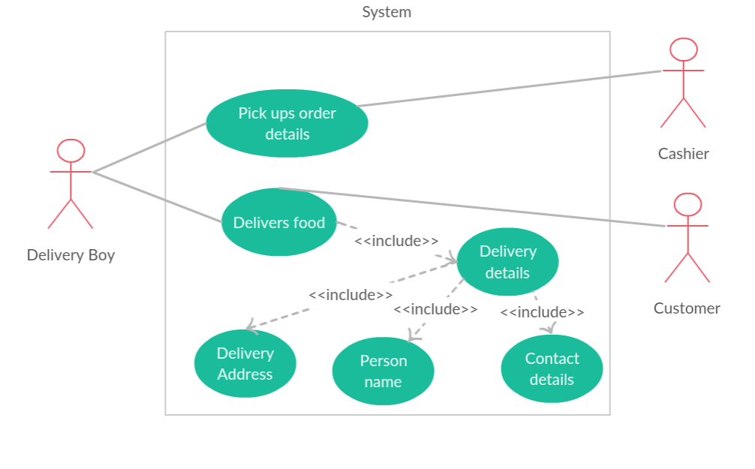

Figure 4 Use Case Diagram for Delivery Boy

**6.1) Pickups order details**

6.1.1) Brief description

Delivery boy receives order details from cashier.

6.1.2) Pre-conditions

A confirmed order must be received by cashier to be able to give it to the delivery boy.

6.1.3) Flow of events

Delivery boy takes the order details which includes all the delivery details, customer name and his contact details

6.1.4) Basic flow

Delivery boy takes the order details, which to be delivered from the cashier

6.1.5) Alternative flow

Delivery boy tries to deliver the order but customer may change the order delivery to pick up at store.

6.1.6) Exception flow

Delivery boy takes the order to be delivered from the cashier and tries to deliver the order but the customer may not show up to pick up or delivery boy may pick up the wrong order to be delivered.

6.1.7) Post-condition

After taking the order details food is delivered to the customer

6.2) Delivers food

6.2.1) Brief description

The food is being delivered to the customer by the delivery boy

6.2.2) Pre-conditions

The delivery time must be with in the store hours

6.2.3) Flow of events

After the pick up details is received by the customer, the food is delivered by the customer boy

6.2.4) Basic flow

1. The delivery boy will have the order details by the cashier

2. The delivery boy delivers the food to the customers

6.2.5) Alternative flow

Delivery boy tries to deliver the order but customer may change the order delivery to pick up at store.

6.2.6) Exception flow

The delivery boy may not deliver the food to the customer

6.2.7) Post condition

The details of the delivery such as the successful delivery or failed delivery must be updated.

**7) Manager**

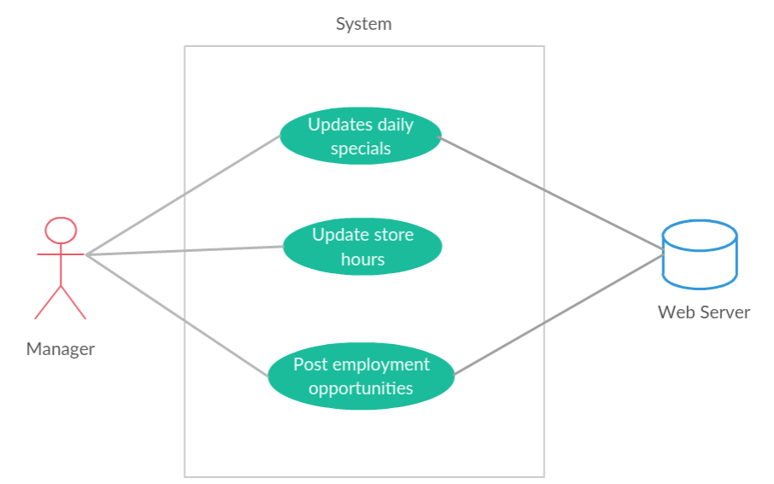

Figure 5Use Case Diagram for Manager

**7.1) Updates Daily Specials**

7.1.1) Brief description

Menu and deals may change according to the chef. The cost of each item may change over a period.

7.1.2) Pre-conditions

Daily menu should be made available for the customer to order

7.1.3) Flow of event

Manager collects the daily special from the chef and updates it in the website daily.

7.1.4) Basic flow

a) Manager Logins to the website

b) Manager updates special menu and deals.

c) Manager Logouts from the website.

7.1.5) Alternate flow

Some part of the menu need not be updated.

7.1.6) Exception flow

The daily specials are out of stock and customer is not able to order the menu he wants

7.1.7) Post-conditions

Manager Logouts from the website.

**7.2) Updates Store Hours**

7.2.1) Brief description

Store hours may be changed due to any technical issues.

7.2.2) Pre-conditions

Manager Logins to the website

7.2.3) Flow of events

Manager decides the store hours and updates it in the website.

7.2.4) Basic Flow

a) Manager Logins to the website

b) Manager updates store hours.

c) Manager Logouts from the website.

7.2.5) Alternative flow

Store hours need not be updated daily

7.2.6) Exception flow

No Exception flow.

7.2.7) Post-condition

Manager Logouts from the website

**7.3) Post Employment opportunities**

7.3.1) Brief description

Available employment opportunities are posted and displayed online

7.3.2) Pre-conditions

There must a vacant opportunity to be posted online

7.3.3) Flow of events

The applicant looks for a vacant job online reads the job title and description and applies for it

7.3.4) Basic flow

a) Manager Logins to the website

b) Post employment opportunities

c) Manager Logouts from the website.

7.3.5) Alternative flow

The manager can also post vacant jobs in the notice board

7.3.6) Exception flow

There will be no exception flow.

7.3.7) Post- conditions

Manager Logouts from the website.

**8. Cashier**

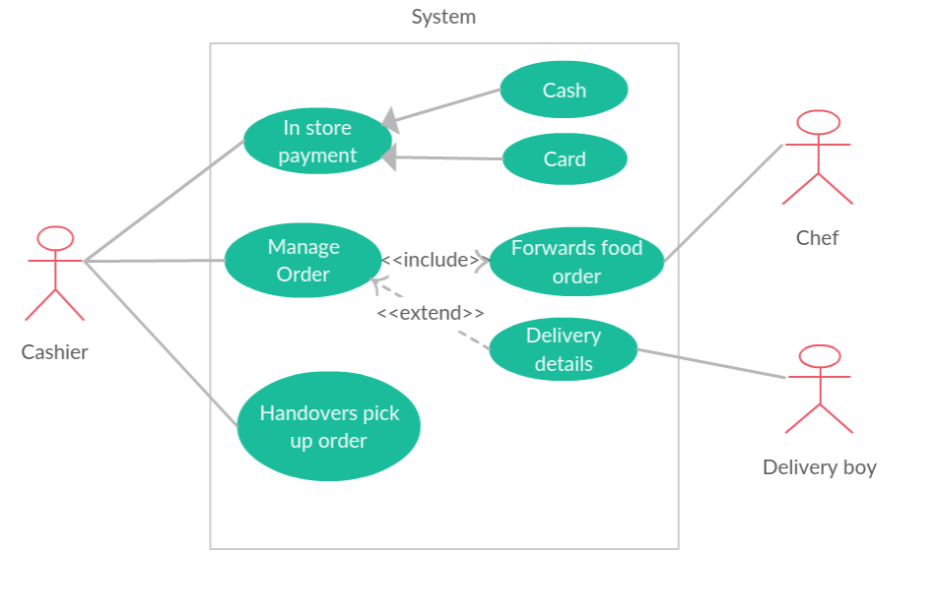

Figure 6 Use Case Diagram for Cashier

**8.1) In store Payment**

8.1.1) Brief description

Customer should pay money before he/she gets food in the store.

8.1.2) Pre-conditions

No pre-conditions

8.1.3) Flow of events

Cashier may receive the payment.

8.1.4) Basic Flow

1. Customer pays money
2. Cashier receives payment
3. Cahier gives the receipt to the customer.

8.1.5) Alternative flow

Customer can pay money through cash or card.

8.1.6) Exception flow

No exception flow

8.1.7) Post-condition

Customer receives the receipt.

**8.2) Manage order**

8.2.1) Brief description

Cashier receives the order, he/she passes it to the chef. If there is any delivery then cashier passes the delivery details to the delivery boy.

8.2.2) Pre-conditions

Payment should be done by the customer.

8.2.3) Flow of events

Cashier received the order and manages it accordingly.

8.2.4) Basic Flow

1. Cashier receives the order
2. Passes it to the chef for preparation
3. Cashier passes the delivery details to the delivery boy if any.

8.2.5) Alternative flow

No alternate flow

8.2.6) Exception flow

Customer may change the delivery details.

8.2.7) Post-condition

Cashier keeps the record of receipts.

**8.3) Handover pickup order**

8.3.1) Brief description

Customer may choose pickup at store while ordering his/her food.

8.3.2) Pre-conditions

Customer should opt pickup at store option.

8.3.3) Flow of events

Cashier handover the order to the customer.

8.3.4) Basic Flow

1. Customer goes to the store for the pick up
2. Cashier handovers the required order to the customer.

8.3.5) Alternative flow

No alternate flow.

8.3.6) Exception flow

Customer may fail to come to store.

8.3.7) Post-condition

Customer receives the receipt from the cashier.

**TASK ANALYSIS**

Figure 7 Task Analysis